Home task 4

1. Design NFA which accepts all inputs with a 11 and also construct DFA.
2. Design an NFA that accepts all inputs with a triple letter like 111 ,000.
3. Convert the following NFA TO an equivalent DFA.

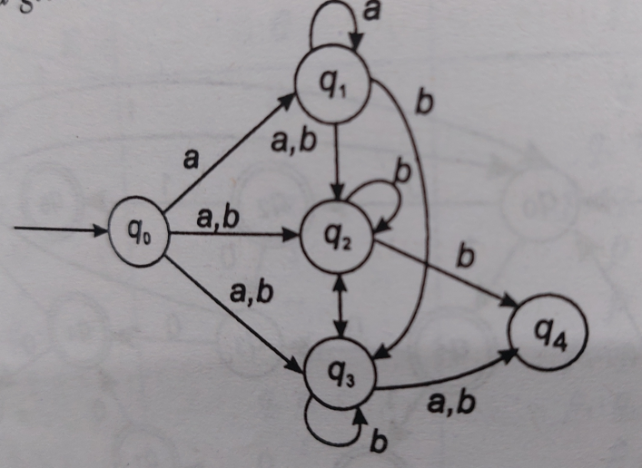

1. Convert the following Epsilon NFA TO an equivalent DFA.

